CLASS SYLLABUS
Advanced Audio/Video Production 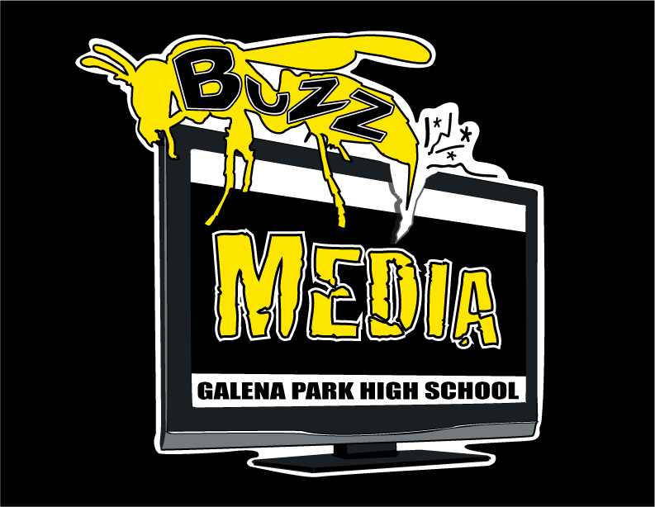

Course Description:
Careers in audio and video technology and film production span all aspects of the audio video communications industry. Within this context, in addition to developing
advanced knowledge and skills needed for success in the Arts, Audio/Video
Technology, and Communications career cluster, students will be expected to develop an advanced understanding of the industry with a focus on pre-production, production, and post-production activities. Students will run the TV broadcast on campus.

For any and all concerns regarding the class and the program please contact me at
832-386-2952 or aftorres@galenaparkisd.com

Please visit our website:
gpbuzzmediaproductions.weebly.com

Grading
50% Daily Work/Participation
50% Tests/Projects

CLASS RULES
- RESPECT OTHERS
- FOLLOW ALL INSTURCTIONS
- WORK AS A TEAM
- EXPECT MORE
- ASK
- NEVER GIVE UP

CLASS EXPECTATIONS
- Be Prepared
- Be Prompt
- Be Positive
- Be Productive
- Be a Problem Solver

It is the responsibility of the student to acknowledge all expectations.

Parent Signature:_______________________________________________ Date:________________

Student Signature:_______________________________________________ Date:________________

